**Electro Statics**

**Elecrostatics:** It’s a branch of Physics deals with study of properties

associated with Stationary charges.

**Electric Field:** An electric field is a vector field surrounding an electric charge that exerts force on other charges.

**Electric Potential:** It is the amount of work done to move unit positive charge from infinity to a particular point inside the field.

**Dipole:** Electric dipole is an arrangement which consists of two equal and opposite charges +q and -q separated by a small distance 2a. Electric dipole moment is represented by a vector **p** of magnitude 2qa and this vector points in direction from -q to +q.

**Electric Potential Due to Dipole**

consider charge -q is placed at point P and charge +q is placed at point Q as shown below in the figure.  
  
  
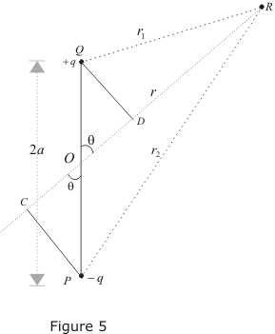 

Since electric potential obeys superposition principle so potential due to electric dipole as a whole would be sum of potential due to both the charges +q and -q.

Thus https://physicscatalyst.com/elec/elecpot_eq15.png   
where r1 and r2 respectively are distance of charge +q and -q from point R.

Now draw line PC perpendicular to RO and line QD perpendicular to RO as shown in figure.

From triangle POC  
cosθ=OC/OP = OC/a  
therefore OC=acosθ similarly OD=acosθ  
Now ,  
r1 = QR≅RD = OR-OD = r-acosθ  
r2 = PR≅RC = OR+OC = r+acosθ  
https://physicscatalyst.com/elec/elecpot_eq16.png   
since magnitude of dipole is   
|**p**| = 2qa  
  
https://physicscatalyst.com/elec/elecpot_eq17.png

If we consider the case where r>>a then  
  
https://physicscatalyst.com/elec/elecpot_eq18.png   
again since pcosθ= **p**·**rˆ** where, **rˆ** is the unit vector along the vector OR then electric potential of dipole is   
  
https://physicscatalyst.com/elec/elecpot_eq19.png   
for r>>a

From above equation we can see that potential due to electric dipole is inversely proportional to r2 not ad 1/r which is the case for potential due to single charge.

Potential due to electric dipole does not only depends on r but also depends on angle between position vector **r** and dipole moment **p**.

**Dielectric Constant**: Faraday discovered that the capacitance of the capacitor increases when dielectric material is placed between the plates.

If Co is the capacitance of a capacitor without dielectric and C is the capacitance of a capacitor with dielectric, then the ratio C/Co gives εr called relative permittivity or dielectric constant. For vacuum εr =1 and for an isotropic material, the electric flux density [D] is related to the applied field strength [E] by the equation, or D=ε E, where ε is the absolute permittivity of the medium. The relative permittivity is given by the ratio of absolute permittivity of the medium to permittivity of free space i.e., 

**Types of Dielectrics**:

Dielectrics are classified into two categories viz., polar and non-polar dielectrics.

**Polar Dielectrics**: Polar dielectrics are those whose effective center of positive and negative charges in the molecules do not co-inside with each other in the absence of external field. These positive and negative charges are separated by a certain distance. Such a pair is referred to as permanent dipoles and these dipoles are oriented randomly which results in net zero dipole moment.

Ex: H2O, HCl, CO, N2O, NH3

**Non Polar Dielectrics**: In non-polar dielectrics the effective centers of positive and negative charges coincide with each other in the absence of external electric field.

Ex: O2, N2, H2, CO2

**Electric Polarization:**

When a dielectric material is subjected to the influence of electric field, the charges are polarized which gives rise to dipole moment. The induced dipole moment / unit volume of the dielectric is called the polarization [P] whose direction is along the applied field.

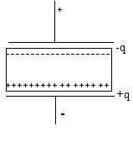If +q and –q are the charges induced on the respective faces of dielectric slab of thickness t kept between the two plates of a capacitor then,

The dipole moment of dielectric material = 

If A is the area of the two faces then, volume = 

The magnitude of the polarization P is = 

= 



**Relation between Polarization P, dielectric Constant  and Susceptibility:**

Consider a parallel plate capacitor with plates between which an electric field Eo exists. If  is the space charge/unit area on the plates, then from Gauss law we have, 

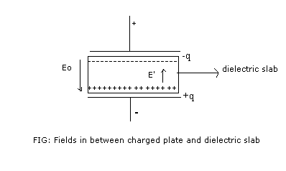 Let the given dielectric slab be placed between the two plates. Due to polarization, charges appear on the two faces of the slab, and establish yet another field within the dielectric. Let this field be E’. The direction of E’ will be opposite to that of Eo.

Therefore the resultant field E in the material can be written as,



If is the charge/unit area on the slab surfaces, then by eqn (1)



From equations (1), (2) and (3),



Magnitude of polarization P= Induced charge/unit area,



Also by Gauss law, we know that D= σ, where D is the electric flux density or electric displacement







Where  is the dielectric susceptibility of the material.

**Bound charges due to electric polarization.**

An external electric field that is applied to a dielectric material, causes a displacement of bound charged elements. These are elements which are bound to molecules and are not free to move around the material. ... The net charge appearing as a result of polarization is called bound charge.

[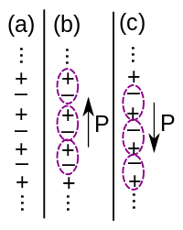](https://en.wikipedia.org/wiki/File:BulkPolarizationIsAmbiguous.svg)

Example of how the polarization density in a bulk crystal is ambiguous. (a) A solid crystal. (b) By pairing the positive and negative charges in a certain way, the crystal appears to have an upward polarization. (c) By pairing the charges differently, the crystal appears to have a downward polarization.

The polarization inside a solid is not, in general, uniquely defined: It depends on which electrons are paired up with which nuclei.

A bound charge is one that cannot move macroscopically in response to an external electromagnetic force (e.g., from an electric field). Charges on the surface of an insulator are an example of this. However, *microscopic*movement is allowed. For example, atoms in an insulator may undergo charge separation when subjected to an electric field, resulting in the formation of dipoles that align themselves so as to counteract the applied field. A useful rule of thumb (not always true, but close) is that bound charges can only move across atomic-scale distances or less.  
  
A free charge is one that is not subject to these constraints. An example would be electrons in a conductor, which are free to move throughout the material. Electrons

**Types of Polarization**:

There are 4 different mechanisms through which electrical polarization can occur.

**Electronic Polarization**: This occurs due to displacement of positive and negative charges in a dielectric material when electric field is applied. Hence dipole moment is induced in the material. The net dipole moment in the material is the vector sum of individual dipoles.

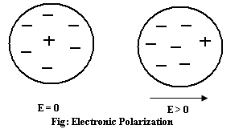

 

Where, μe is the electronic dipole moment

αe is the electronic polarizability

E is the electric field strength

The Electronic Polarization P = Nμe = NαeE

Where, N is the total number of atoms /unit volume.



**Ionic Polarization:** This polarization occurs only for those dielectric materials which possesses ionic bonds such as NaCl. When ionic solids are subjected to an external electric field the adjacent ions of opposite sign undergo displacement. This displacement causes an increase in the distance between the ions and results in a net dipole moment.

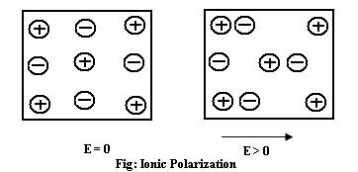

The induced dipole moment is also directly proportional to applied field strength.

 μi = αiE

Where μi is the ionic dipole moment,

αi is the ionic polarizability

And also ionic Polarization, 

**Orientational Polarization:**

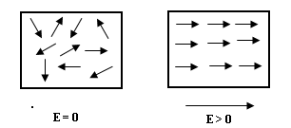



This occurs in polar dielectric material whether solids or liquids which possesses molecules with permanent dipole moment. In polar dielectrics the dipoles are randomly oriented due to thermal agitation. So the net dipole moment is zero. But when the electric field is applied all the dipoles tend to align along the direction of the applied field. This is referred to as Orientational polarization (Po). The Orientational polarization is strongly dependent on temperature which decreases with increase of temperature. In case of polar dielectrics; Orientational polarizability is αo is given by,



Where, k is the Boltzman constant.

T is the absolute temperature

μ is the Orientational permanent dipole moment.

The Orientational Polarization is given by 

**Space Charge Polarization**: In some dielectrics there may be deviations from periodic arrangement of atoms due to vacancies or presence of impurity atoms. So there can be inclusion of additional phase.

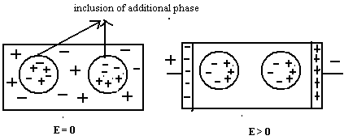



When an electric field is applied, the charges move through the material to its surface. Immobile inclusions get polarized as shown in the diagram. The surface of material near positive electrode acquires a negative charge and near the negative electrode acquires a positive charge. The total polarization of a material is given by,

P = Pe + Pi + Po

The Space Charge Polarization is not an important factor in most common dielectrics. Among all the polarization electronic and ionic polarization are insensitive to temperature changes.

**Internal Field or Local field**:

The net electric field at any point within the dielectric material is given by “the sum of external field and the field due to all dipoles surrounding that point”. This net field is called internal field or local field.

**Expression for internal field in case of solids and liquids in one dimension:**

Consider a dielectric material kept in uniform electric field of strength E. Consider an array of equidistant dipoles within the dielectric material, which are arranged parallel to the direction of the field as shown in figure. Let the interatomic distance be ‘a’.

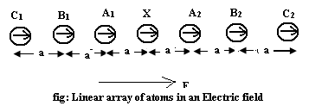

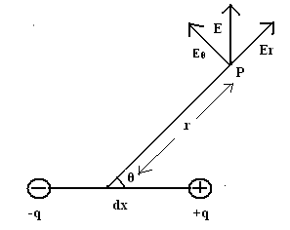In the linear array let us consider the atom X. At X the total field due to all the other dipoles in the array can be evaluated as follows.

The field at X due to the dipole A1 is given by 

The distance of X from A1 is d and directions of dipole moment of both are collinear.



 Hence 

 

The field X due to dipole A2 is given by, 



Hence 



 The field E1 at X due to equidistant dipoles A1 and A2 is given by,

= +



Now, if we consider 2 dipoles B1 and B2 each of which is located at a distance of 2d, then the field at X due to both of them is given by,



Similarly the field E3 at X due to the dipoles C1 and C2 is given by,



The total field E1 induced at X due to all dipoles in the linear array is



++



 



The total field at X which is the internal field or Local field Ei is the sum of applied field E and field due to all the dipoles i.e., E1





For three dimensions the above equation can be generalized by replacing 1/a3 by N (where N is the number of atoms per unit volume) and 1.2/Π by ν called Internal Field Constant.



But polarization 

Since ν, P and εo are positive quantities Ei > E. For a cubic lattice ν = 1/3 and the local field is called **Lorentz field**. It is given by,



**Applications of Dielectric Materials:**

1. Plastic and rubber dielectric are used for the insulations of electrical conductors.

2. Ceramic beads are used for the prevention of electric short circuiting

3. Mica and asbestos insulation is provided in electric iron in order to prevent the flow of electric current to outer body

4. Varnished cotton is used as insulators in transformers.

5. Dielectric materials are in the capacitors to store the energy

6. Piezo-electric crystals are used in oscillators and in vibrators**.**